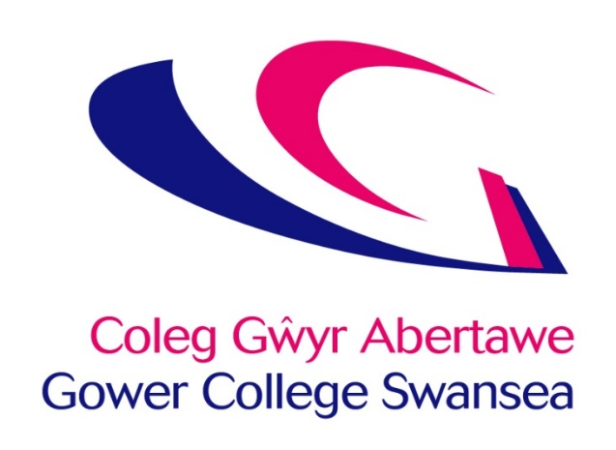

Slavery and Human Trafficking Statement
December 2024
Gower College Swansea (“the College”) is a College of Further Education based wholly in the United Kingdom. The College campuses are sited in Swansea, Wales and the College provides education and training across the UK. The College has around 4,300 full time students, 2,500 apprentices and 3,500 part time learners.
The College believes that when acquiring goods and services, it is crucial that it is done so without causing harm to others, and is fully committed to acting ethically and with integrity in all its business dealings and relationships.

In so doing, the College supports the UK Government’s approach to implementing the UN Guiding Principles on Business and Human Rights by informing our staff, students, governors and stakeholders about our policy with respect to modern slavery, human trafficking, forced and bonded labour, and labour rights violations in its supply chains.
Welsh Government has issued the Code of Practice – Ethical Employment in Supply Chains to help address the issues of modern slavery. The College has identified a number of actions identified within the 12 Commitments identified within the code.
The College purchases many of its goods and services from public sector purchasing consortia. The principal consortia used by the College are:
- National Procurement Service (NPS)
- Crescent Purchasing Consortium (CPC)
- Higher Education Purchasing Consortium for Wales (HEPCW)
- The University Catering Organisation (TUCO)
These consortia are developing processes to manage supply chain risk relating to slavery and human trafficking. In addition, the consortia have published their own Slavery and Human Trafficking Statements which state how they aim to address these issues through the procurement processes that they manage.

The College has identified the following categories as of being of high risk - Clothing, Food, ICT Equipment.

Looking to the future, the College expresses its commitment to:
- Better understand our supply chains and work towards greater transparency and responsibility towards the people working within them.
- Monitor areas that represent a risk, working with suppliers, framework organisations and franchisees.
- Mitigate the risk of slavery and human trafficking occurring in our supply chains and take the appropriate action if necessary.

This statement is made pursuant to section 54(1) of the Modern Slavery Act 2015 and constitutes the College’s slavery and human trafficking statement for the financial year ending 31 July 2024.
This statement was approved by the Corporation Board of Gower College Swansea at its Board Meeting on 12 December 2024.
Meirion Howells
Chair of the Corporation Board of Gower College Swansea
12 December 2024

